

TECHNICAL UNIVERSITY OF KENYA
FACULTY OF APPLIED SCIENCES AND TECHNOLOGY
SCHOOL OF COMPUTING & INFORMATION TECHNOLOGY
END OF SEMESTER MAY2017 EXAMINATION SERIES
FIRST SEMESTER EXAMINATIONS 2016/2017
THIRD YEAR EXAMINATIONS FOR THE DEGREE OF
BACHELOR OF TECHNOLOGY IN COMPUTER TECHNOLOGY
BACHELOR OF TECHNOLOGY IN INFORMATION TECHNOLOGY
BACHELOR OF TECHNOLOGY IN COMMUNICATION AND COMPUTER NETWORKS
ECSI 3106/ECII 3106/ECCI 3106:OBJECT ORIENTED SYSTEM ANALYSIS AND DESIGN
TIME: 2 Hours MAY 2017
Instructions to candidates:
This paper consists of FIVE Questions.
Answer Question ONE [30 Marks] and any other TWO Questions [20 Marks Each].
Mobile phones and any written materials are prohibited in the examination room.
Programmable calculators are prohibited
Write your college number on the answer sheet.
This paper consists of 3 printed pages
Candidates should check the question paper to ascertain that all the pages are printed as indicated and that no questions are missing.
@May 2017 The Technical University of Kenya

QUESTION ONE[30 MARKS] (COMPULSORY)

- Define the term object oriented design. (2marks)
- i. What is the Object Modeling Techniques (OMT) (2marks)
ii. Compare Object Oriented Analysis and Design & Structured System Analysis and Design.
(4marks)
- i.Explain the different goals of UML. (3marks)
ii.Differentiate between class notation and object notation in UML. (4marks)
- i.What is Unified Process Model? (2marks)
ii. Describe “Object-Oriented Software Life Cycle. (4marks)
- The goal of Analysis model is to develop a model of what the system will do.
- Draw Analysis model for Banking System. (4marks)
- Draw the activity diagram of ATM Machine system (5marks)

QUESTION TWO [20 MARKS]
Study the diagram below and answer the questions that follow
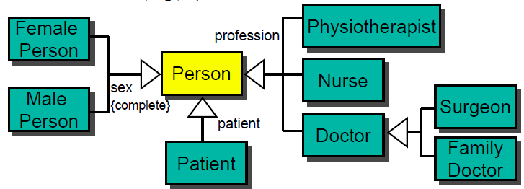

- Provide the scenario for the above diagram (10 marks)
- Provide a list of aggregations (4 marks)
- Identify the super classes and subclasses (4 marks)

- Provide the association between Doctor on one side and Surgeon and Family doctor on the other. (2 marks)

QUESTION THREE [20 MARKS]
- Define the term object oriented design. (2 marks)
- Explain with an example each the following concepts used in object-orientation
- Single inheritance (4 marks)
- Multiple inheritance (4 marks)
- i.Explain the meaning of the term modeling. (2 marks)
ii.Explain briefly why modeling is important. (2marks)
ii.Describe brieflythree types of modeling. (6marks)

QUESTION FOUR [20 MARKS]
a)i.Explain the meaning of object-oriented design model. (2marks)
ii. Graphical notations are well suited for documenting the fine details of a system specification. Discuss the correctness of this statement. (4marks)

b) Write a short note on Object-Oriented Modeling Technique. (6marks)
c) i. Explain the purpose of a system sequence diagram (2marks)
ii. Draw the sequence diagram of a login page. (6marks)

QUESTION FIVE [20 MARKS]
- Our problem domain is an information system for a video rental store. Simplifying assumptions and details:

- It is a stand-alone store, not part of a larger organization.
- Rents only videos, not computer games or other items.
- A “video” can be in any medium: tape, DVD, and so on.
- The rental charge may vary by medium. For example, DVD rentals are more expensive than tapes.
- The store does not sell anything. For example, there are no sales of videos or food.
- All transactions are rentals.
- The input medium by which membership and video rentals are captured is not important.
- Cash-only payments.
- On completion of a rental, the customer receives a transaction report with ‘typical’ information on—use your judgement.
- Each renter has a separate membership.

Required:
- Identify at least 4 primary use cases and related actors. Draw the results in a UML use case diagram. (4marks)
- Write the Rent Videos use case in expanded, essential, conversational style. Include both a typical course of events, and an alternatives section. (6marks)
- Bounded by the provided Rent Videos use case, create a conceptual model and illustrate it in UML notation. Show concepts, associations, and attributes. (6marks)
- Bounded by the provided Rent Videos use case, create a system sequence diagram in the UML notation. Show actors and system events. (4marks)

